# Activity guide

## Description:

Your mission is to complete the **UserRestTest** & **UserDatabaseTest** testing class and make it bug-free with all passing tests.

These classes contain the methods to be tested.

You need to find what’s wrong and make sure all of them go green.

Second of all, you need to add all of the App class test methods and check whether the following functionalities are working correctly:

- The classes test cases

- make sure all the test cases pass

If these aren’t working, you need to put your debugging hat on and figure out how to get them up and running.

Tests might help you though, but also make sure that the test is also correct. Some debugging might be needed after all.

Deliverable

You’ll submit the complete project as a zipped package. The Notes application is available on this link.

<https://github.com/mshall/JavaTesingtCoursePractical>

## Evaluation:

1. Naming of the test methods

2. All test cases run normally

## Project setup:

1. Download MySQL workbench from the following location: [MySQL-Workbench source](https://www.mysql.com/products/workbench/) During the setup please make sure to set the username=**root** & password=**root**
2. After the setup open the file using notepad: **webticketing-v11.sql**. You'll find it in the Database directory.
3. Now launch **MySQL Workbench**
4. You will find the home screen as in the below image

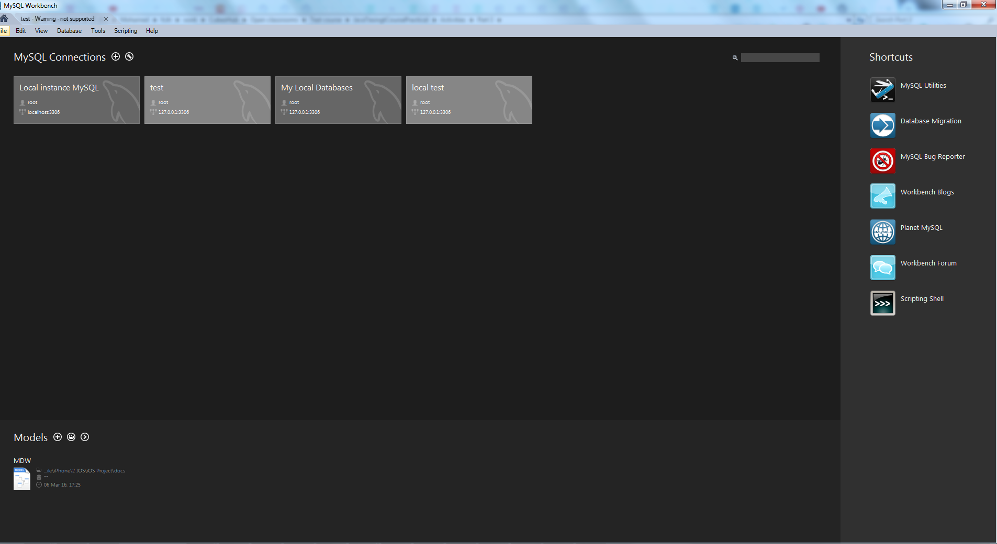

1. Now open the My SQL Local instance
2. You find the screen after loading like this

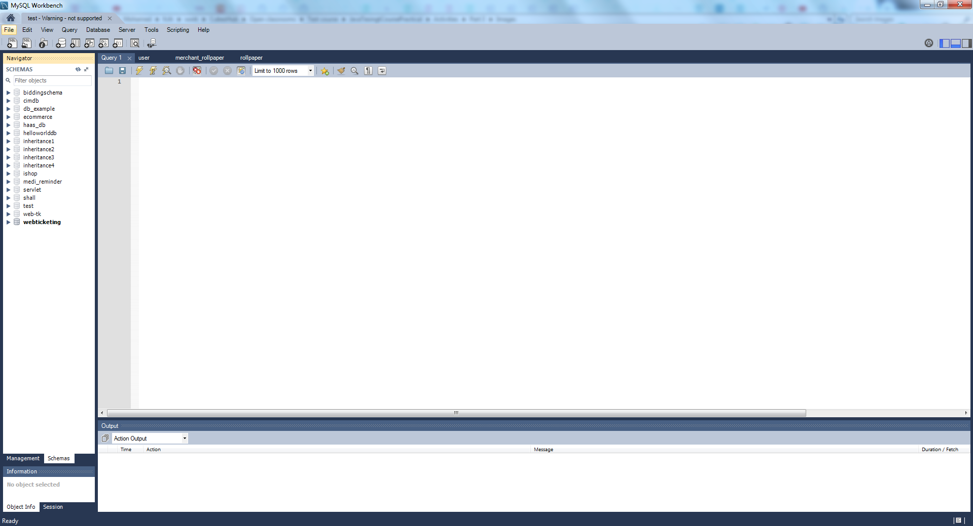

1. Now copy the content of **webticketing-v11.sql** file from notepad
2. Paste it there as in the below screenshot

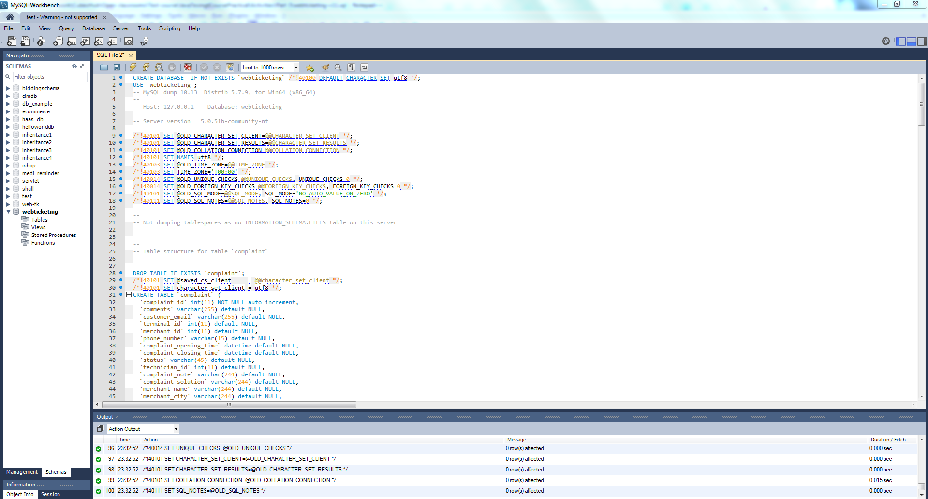

1. In Unsolved directory, you find the project **WebTicketing**, import it in eclipse as a maven project.
2. After importing the project, right click :arrow_right: Maven :arrow_right: Update maven project

* 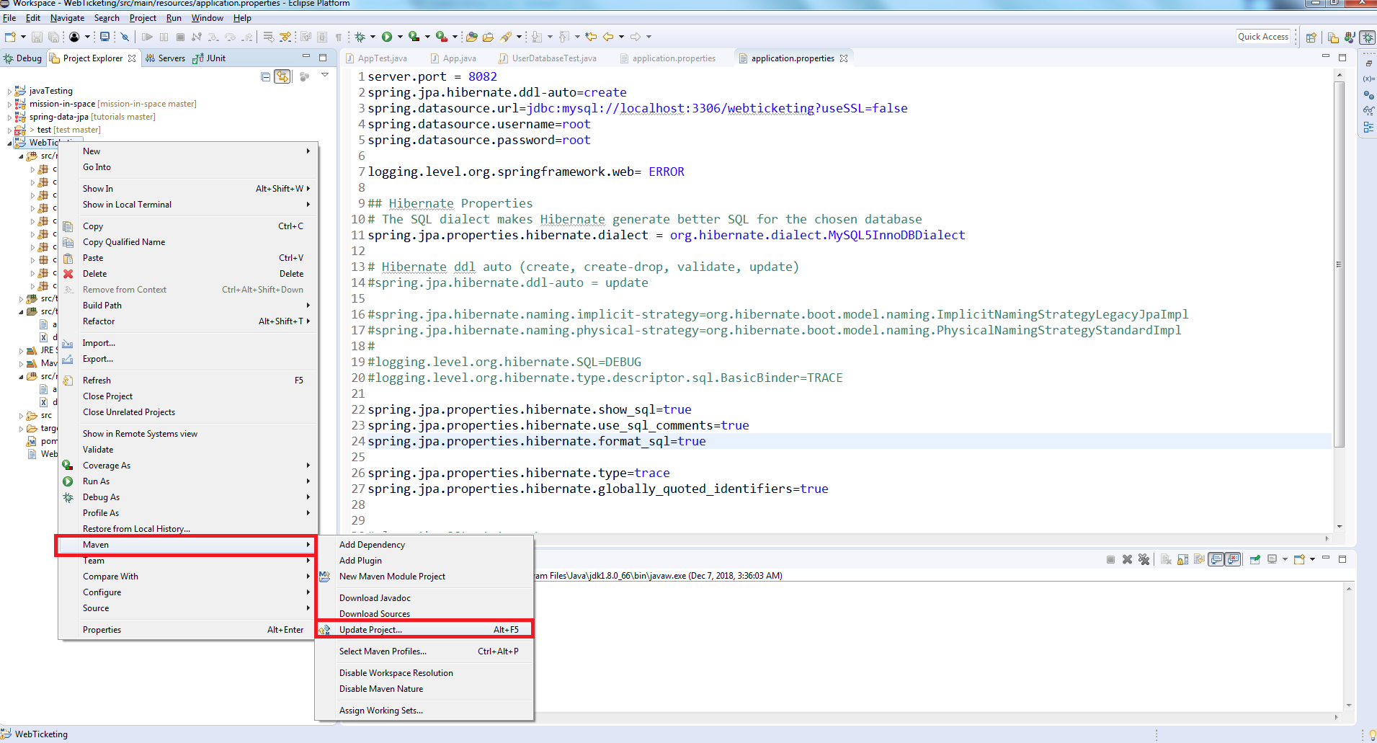

1. Make sure to check the checkbox of force update as in the below screenshot

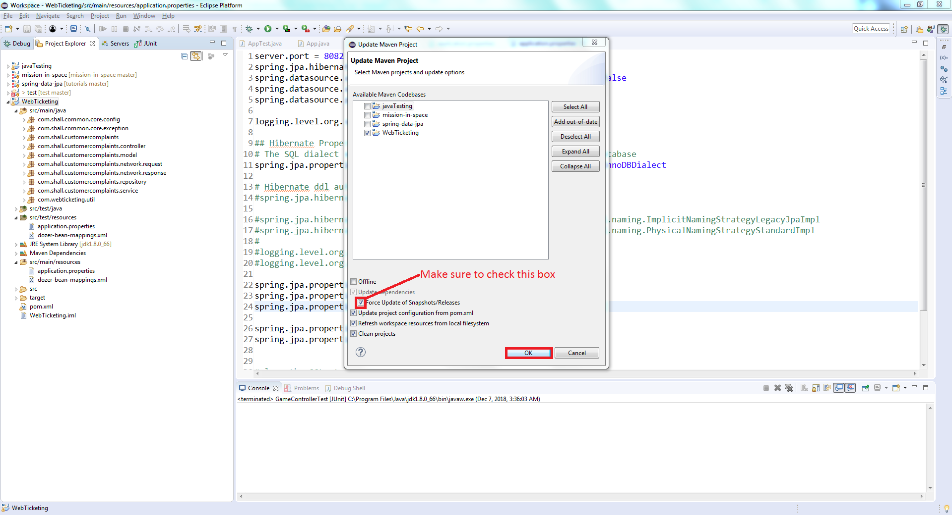

1. After this, we need to make sure that the project java version is set to the JDK, so right click on the project :arrow_right: Properties :arrow_right: Build path :arrow_right: Make sure that the java version there is JDK

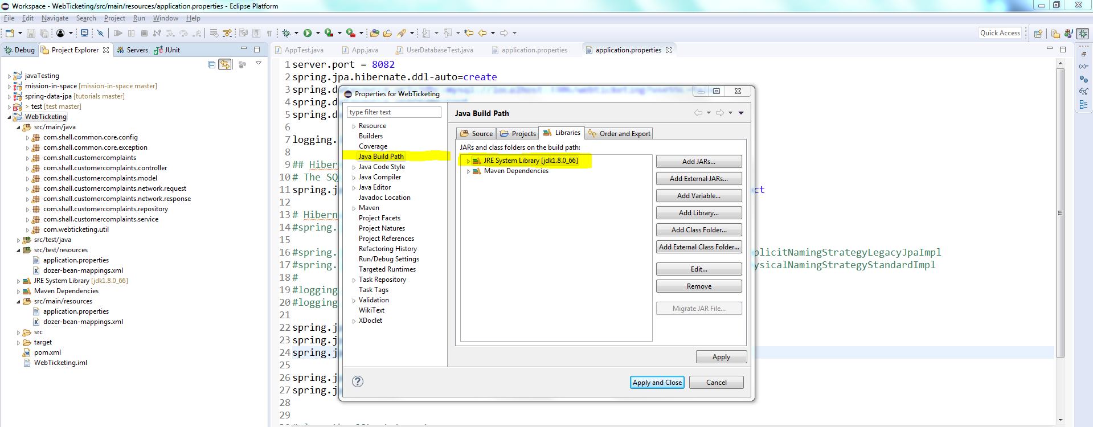

1. From the toolbar :arrow_right: select project :arrow_right: clean

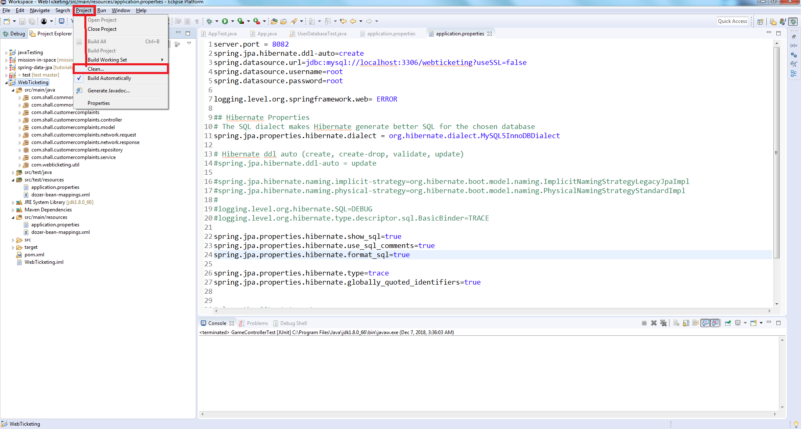

1. Now, right click on the project :arrow_right: Run as :arrow_right: Maven clean
2. Now, right click on the project :arrow_right: Run as :arrow_right: Maven install

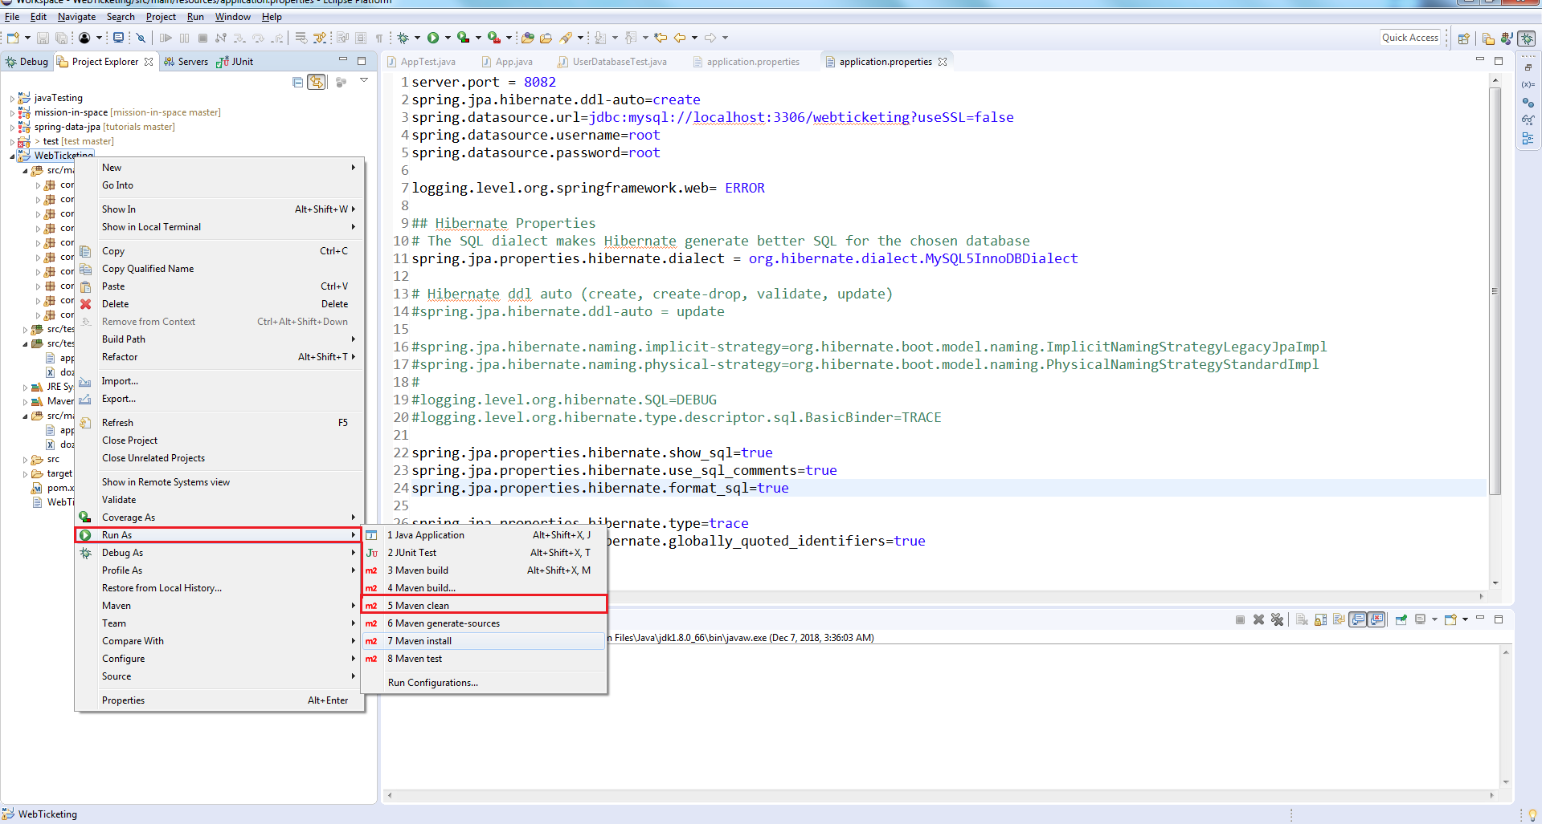

1. Wait until you see the project build as **Build Success**

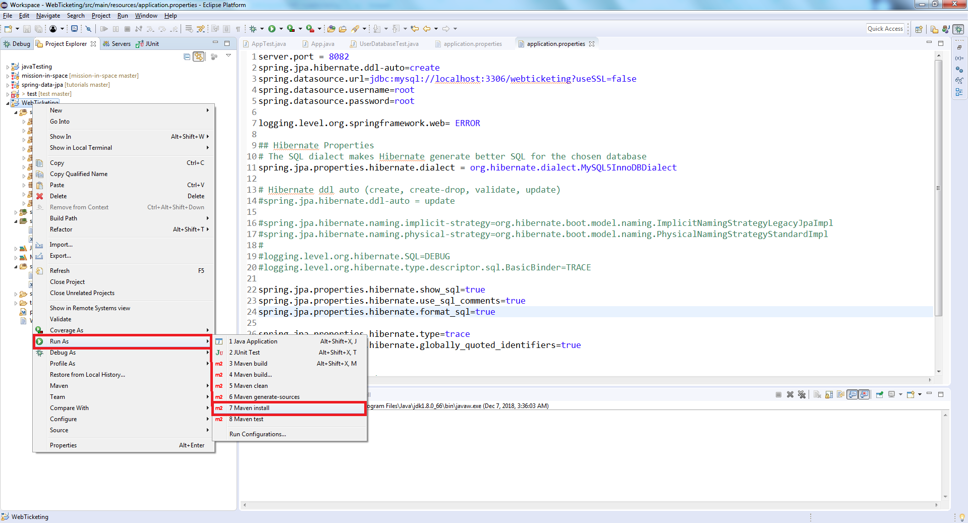

## Activity Instructions:

1. Navigate to the **UserRestTest** under test package > com.shall.customercomplaints.integration.network
2. Un-comment the class comments through CTRL + / or if you're using MAC then cmd + / Then click save
3. Navigate to the **UserDatabaseTest** under test package > com.shall.customercomplaints.repository
4. Un-comment the class comments through CTRL + / or if you're using Mac then cmd + / Then click save
5. Now you can see these test classes we went through the course. Its your turn now to test the following two classes with the same approach
6. First class is: **Complaint controller**. You will find it under the following package > com.shall.customercomplaints.controller
7. Second class is: **ComplaintsRepository**. You will find it under the following package > com.shall.customercomplaints.repository

* You should apply the best practices we took across the course, starting from the class name, method names, test fixtures ...etc.
* There will be peer reviews, which means your colleague will review your work and both will judge each other.
* I left this open without putting what should be added or not as this would motivate you much to follow the best practices and if you apply them then you shall not receive any review comments :)
* Eventually, enjoy :)